Name:______________________________________ Date: ____________ Period: ____
Lesson 2.2.2 Homework Problems 2-51 to 2-55
2-51. Write an expression to represent each of the following sketches. Then give the value of each sketch.
a. 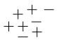 b. 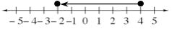

c. 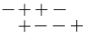 d. 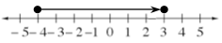

2-52. Use the numbers 5, 6, and 7 and the operations of addition, subtraction, multiplication, and/or division to create three different number expressions with three different values. One of the expressions should have a value of 37.

2-53. Use a number line to show your work as you find the value of each expression.
a. −5 + 3.25

b. 3.18 + (−7)

2-54. Rewrite the following fractions as decimals and decide if they are terminating or repeating decimals. Show your work and explain how you made your decision.
a. b. c. d.

2-55. Evan's uncle gave him money for his birthday.
a. Evan plans to put half of the money in his savings account, spend of the money on bubble gum to share with his friends, and buy comic books with the money he has left. What portion of the money will he spend on comic books?

b. Evan uses some of his comic-book money to buy a magazine for $4. If Evan’s uncle gave him $30, what fraction of this money did he spend on the magazine?

